**Instructions**

Close

**Lab instructions**

0 of 1 completed

Semantic HTML: Enhancing Web Page Accessibility and Structure Lab

​

**Introduction:**

Semantic HTML tags improve the accessibility, readability, and maintainability of web pages by providing meaningful structure. Unlike generic tags like **<div>** or **<span>**, semantic tags like **<header>**, **<nav>**, and **<section>** convey the purpose of the content they enclose. This lab will guide you in converting a non-semantic webpage into a semantic one without altering the content or layout.

**Goal:**

The goal of this lab is to transform a non-semantic webpage into a well-structured, semantic webpage using appropriate HTML tags, ensuring accessibility, clarity, and adherence to modern web development practices while maintaining the page's original content and layout.

**Objectives:**

* Understand the purpose and usage of semantic HTML tags.
* Identify areas in non-semantic HTML that can be improved using semantic tags.
* Center-align elements such as images and text using Bootstrap utility classes.
* Update a given webpage to use semantic HTML while preserving its content and layout.

**Instructions:**

**Part 1: Understanding and Viewing the Initial Webpage:**

**Step 1:** Open the **index.html** file present in the **PROJECT** folder. This file contains a basic webpage layout using non-semantic tags.

**Step 2:** **Analyze the non-semantic tags:** Review the script present in the **index.html** file to understand the structure and identify where generic tags (like **<div>**) are used.

**Step 3: Start the live server and view the webpage layout:**

* At the bottom-right of the editor, click on the **Go Live** button.
* Once the server is up and running, you will see an **exposed port** number (**e.g., 5500**). This means your server is now live.
* At the middle-left of the editor, click on the **Browser Preview** button toopen a new Browser Preview tab.
* In the browser, enter the following URL format (replacing **<exposed port>** with the actual port number shown in the editor): http://localhost:<exposed port>.
* Once the URL is entered correctly, the webpage will load, and you should see the **Welcome to My Blog** webpage based on the default layout defined in the **index.html** file.

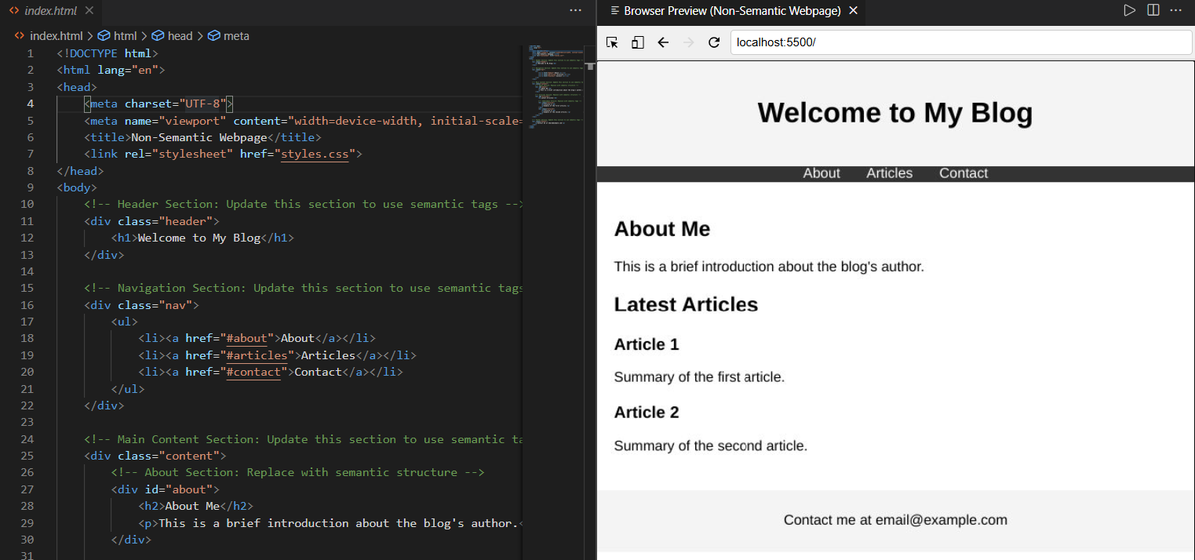

**Part 2: Modify the HTML Structure to Use Semantic Tags:**

**Step 1:** Replace the **<div>** elements with appropriate semantic tags like **<header>**, **<nav>**, **<main>**, **<section>**, **<article>**, or **<footer>**.

**Step 2:** Follow the detailed comments in the provided **index.html** file script to identify where semantic tags should be applied.

**Step 3:** Ensure that the page structure and layout remain unchanged.

**Initial Non-Semantic Example:**

1

2

3

<div class="header">

    <h1>Welcome to My Blog</h1>

</div>

**Refactored (modified) Semantic Example:**

1

2

3

<header>

    <h1>Welcome to My Blog</h1>

</header>

**Part 3: Save and Verify Your Changes:**

**Step 1:** After successfully modifying the **index.html** file, navigate to **File** > **Save** to save changes in the file.

**Step 2:** In the browser preview pane, click the **refresh** button and verify that the layout remains consistent after applying semantic tags in the **html.index** file.

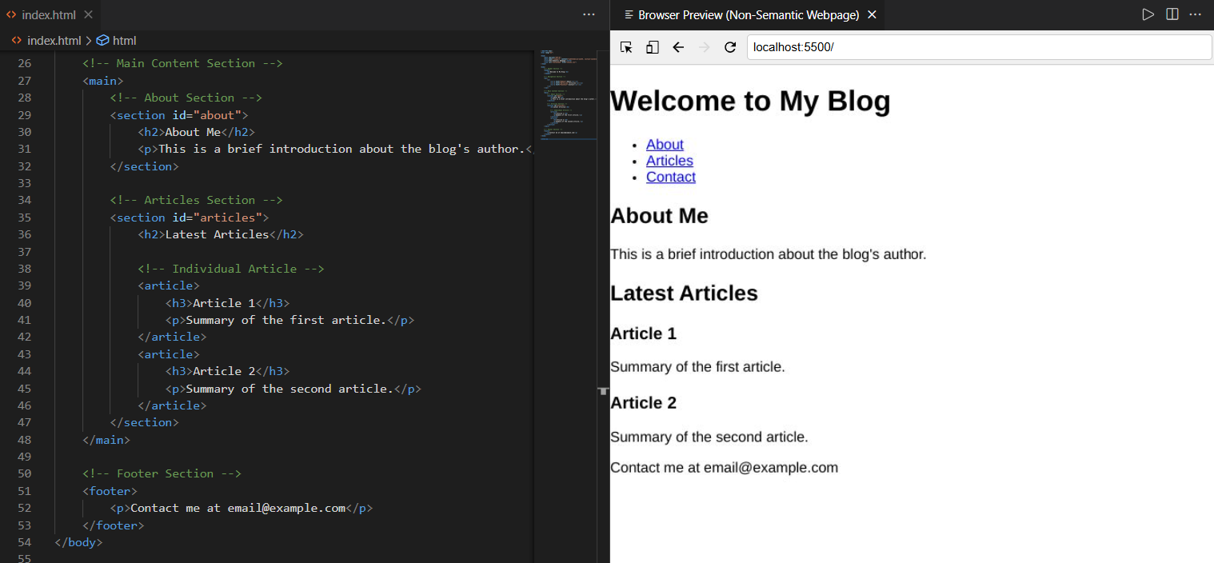

**Step 3:** **Close the server after completing the lab**: Once you’re done with the lab, make sure to **close the server** to free up the port:

* Click on the exposed port number (**e.g., 5500**) at the bottom-right of VSCode.
* You should see a notification confirming that the server is now offline (stopped).

**Key Takeaways:**

* Semantic HTML tags like **<header>**, **<nav>**, **<main>**, **<section>**, and **<footer>** provide meaning to web content, enhancing accessibility and SEO.
* Replacing non-semantic tags improves a webpage's structure and usability without affecting its appearance.
* Validation tools help ensure that your HTML meets web standards and best practices.

**Final Step: Mark as Completed**

* Click the **Mark as Completed** button present below to mark the lab as **Completed**.